[Kavicosmetics](https://kavicosmetics.blogspot.com/?m=1)

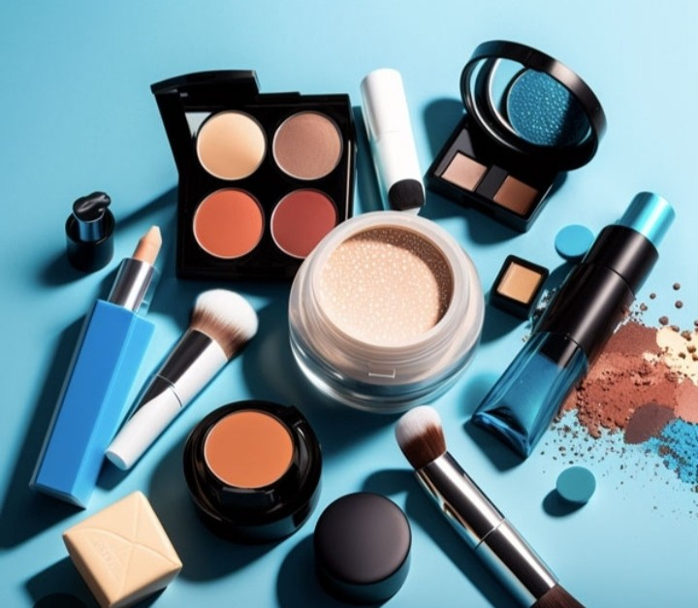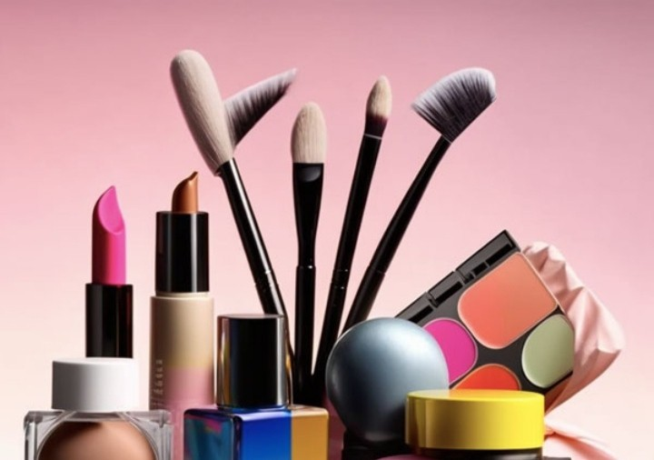

Assignment link

https://kavicosmetics.blogspot.com/2023/10/cosmetics-world.html

**cosmetics world**

[October 11, 2023](https://kavicosmetics.blogspot.com/2023/10/cosmetics-world.html?m=1)

makeup business from an average one? A catchy, memorable slogan or tagline. Yes, the power of a few simple words to deﬁne and promote your brand is often underestimated.

Consider this – slogans have been known to [increase brand recognition by up to 80%](https://www.soocial.com/slogan-statistics/)! Even more intriguing? Companies that harness the power of memorable slogans experience an average revenue growth of 21% more than businesses without slogans.



If you’re on a quest for the perfect slogan or tagline for your [makeup business](https://www.soocial.com/makeup-beauty-business-names/), you’re in the right place. This blog post is a goldmine of unique and captivating slogans and taglines tailored to make your business glow.

Prepare to dive into an ocean of words, from catchy makeup slogans that resonate with all beauty enthusiasts to speciﬁc bridal makeup taglines that paint a picture of a blushing,

beautiful bride. Let’s get your business the attention it deserves!

**Popular posts from this blog**

**[cosmetics world](https://kavicosmetics.blogspot.com/2023/10/cosmetics-world_19.html?m=1)**

*[October 19, 2023](https://kavicosmetics.blogspot.com/2023/10/cosmetics-world_19.html?m=1)*

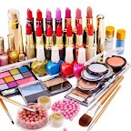#makeup #makeupartist #makeuptutorial #makeupaddict #makeuplover #instamakeup #nomakeup #wakeupandmakeup #makeupjunkie #make upoftheday #makeupbyme#bridalmakeup#makeupforeve […](https://kavicosmetics.blogspot.com/2023/10/cosmetics-world_19.html?m=1)

[r #weddingma](https://kavicosmetics.blogspot.com/2023/10/cosmetics-world_19.html?m=1)

**[READMORE](https://kavicosmetics.blogspot.com/2023/10/cosmetics-world_19.html?m=1)**

[Powered by Blogger](https://www.blogger.com/)[Report Abuse](https://www.blogger.com/go/report-abuse)